**Question 1**

**1.1)**

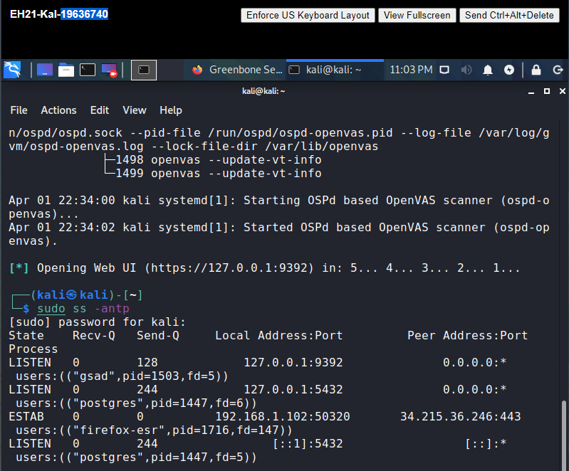

**listening at port 9392, which receives a web interface from GSA.**

**1.2)** sudo runuser -u _gvm -- gvmd --user=admin --new-password=admin123

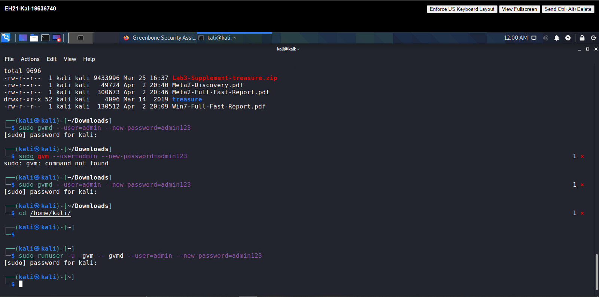

**1.3) both** https://localhost:9392 and https://127.0.0.1:9392

**Question 2**

**2.1)**

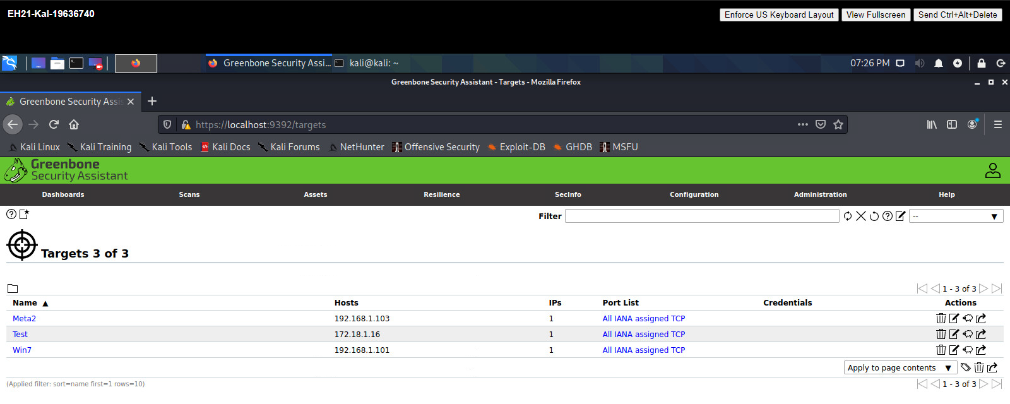

**2.2)**

**A) 5836**

**b) No**

**Question 3**

**3.1)**

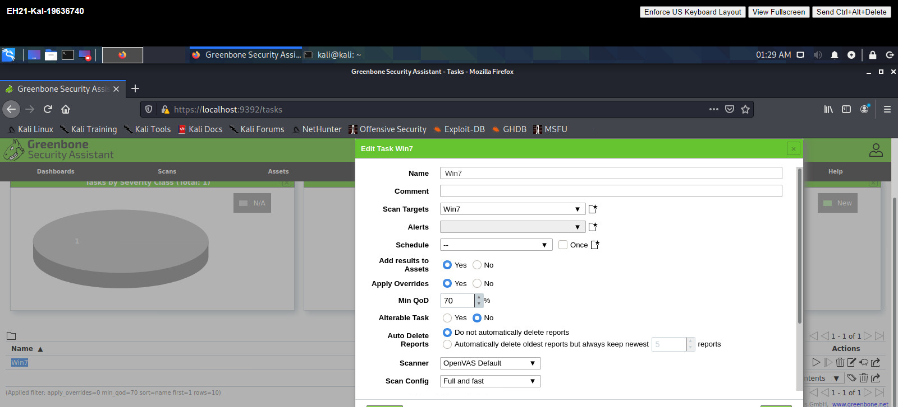

**3.2) 127.5 KiB**

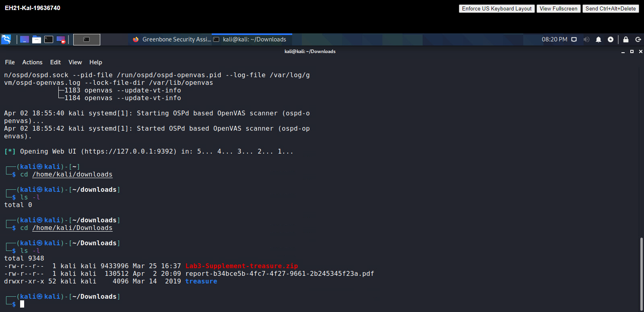

**3.3)**

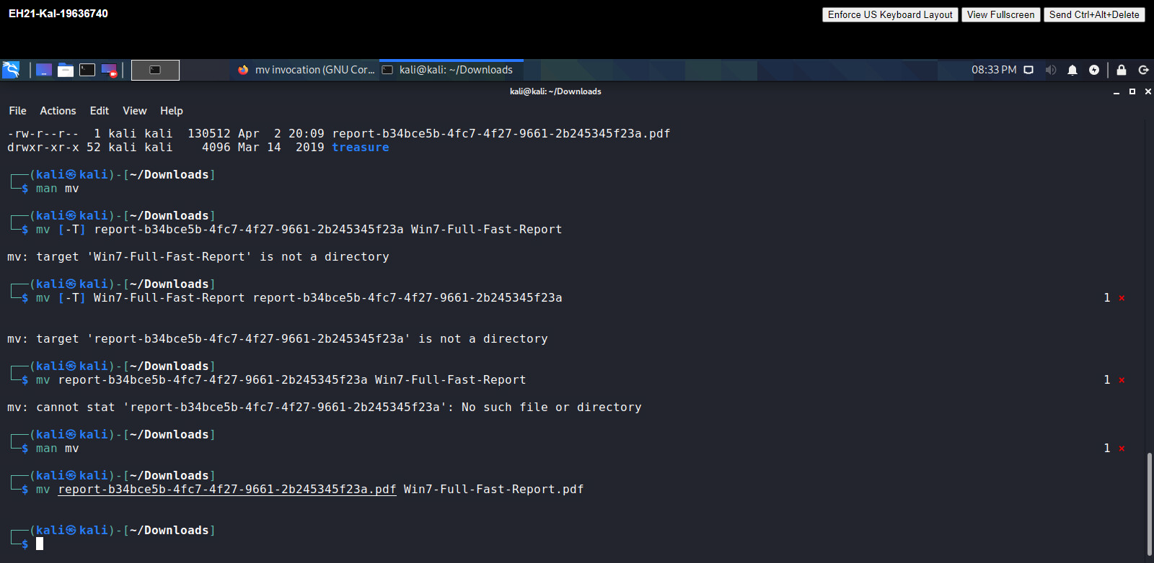

**3.4)**

**A) 3**

**b) 7**

**Question 4**

**4.1)**

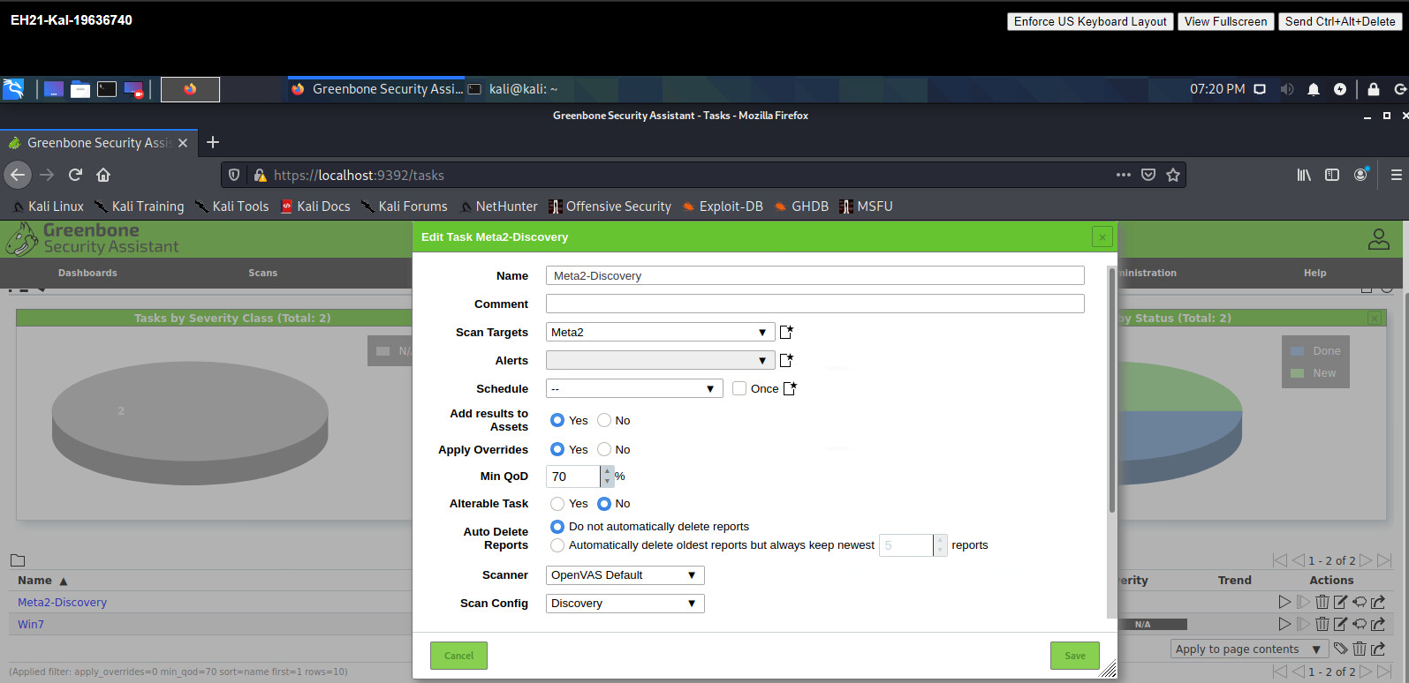

**4.2) 3003**

**4.3) Apr 2 20:40**

**4.4)**

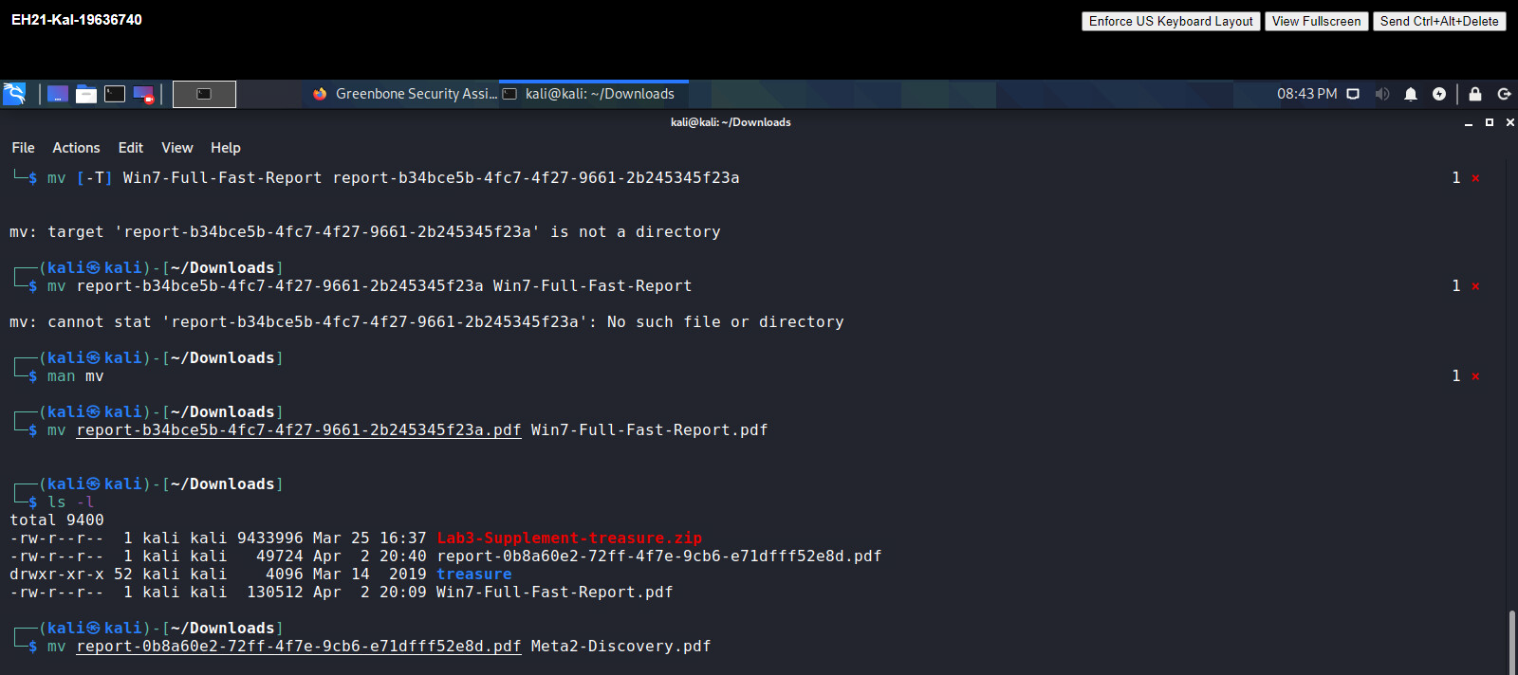

**4.5) 0**

**4.6)**

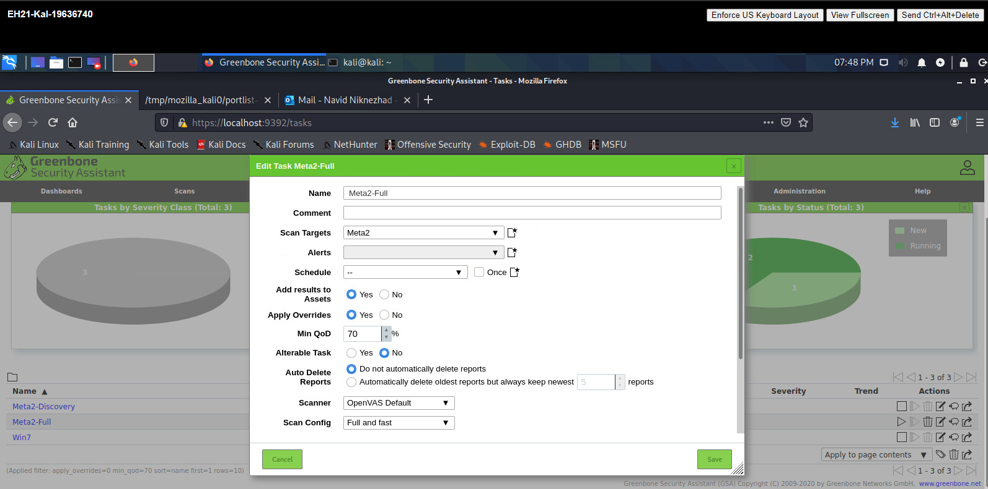

**4.7) 64777**

**4.8)**

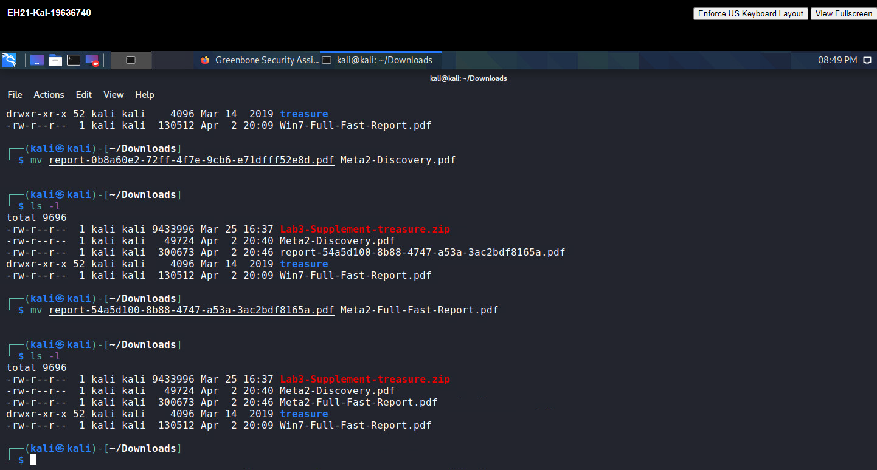

**4.9) 23**

**Question 5**

**5.1**

**a) 4**

**b) Microsoft Windows SMB Server Multiple Vulnerabilities-Remote (4013389)**

**c)**

1. **Vender fix; the vender has released updates.**
2. 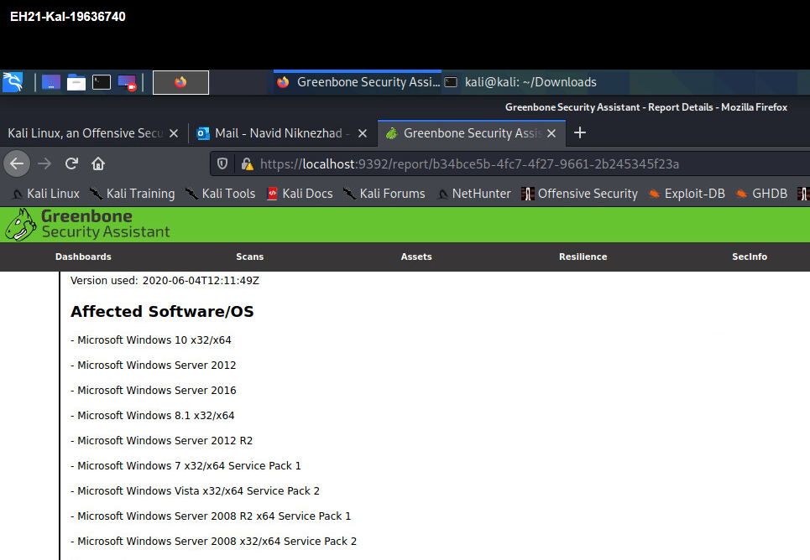

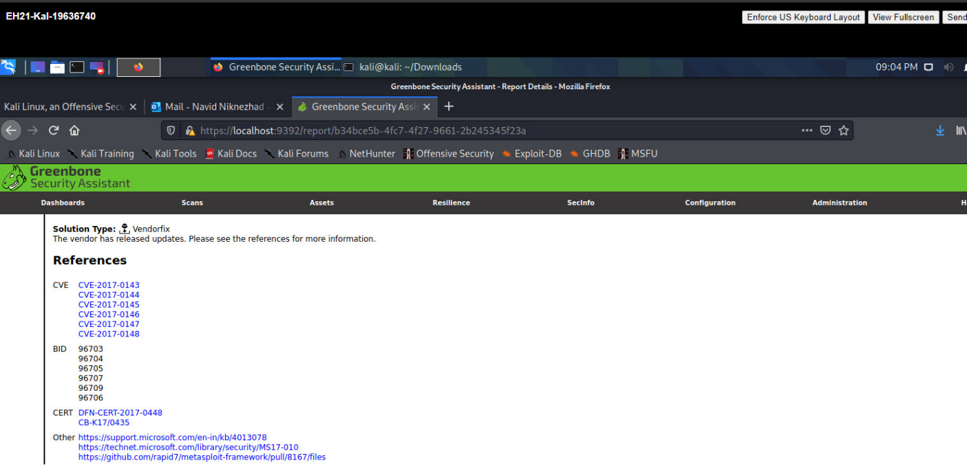

**5.2**

**a) 34**

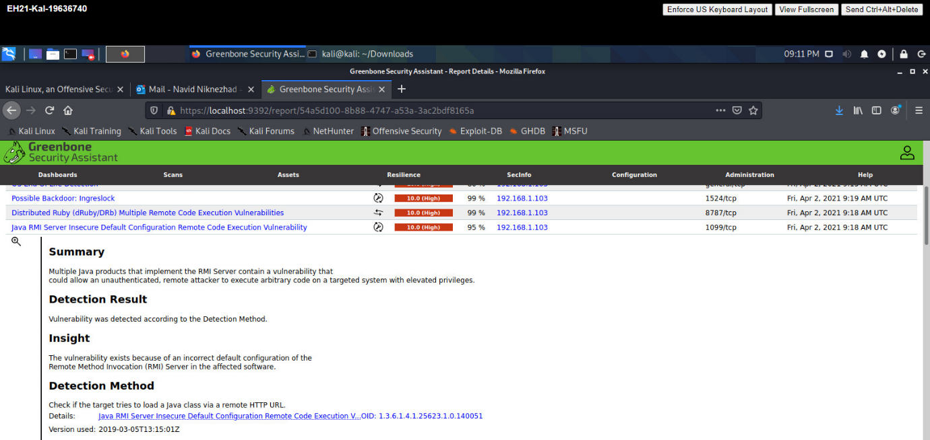**b)**

